Minnie’s Potatoes: Synopsis

“Minnie's Potatoes” is a true story researched from primary and secondary sources and folded into the cultural and political events of the era, a novel of creative non-fiction. The story is of an urban, cultured beauty from late eighteenth century Prussia who has two lovers who happen to be brothers. Pregnant with one brother's child, she travels steerage with her three sons to join her husband, a lumberjack working in the crude, untamed wilderness of Michigan's early lumbering era. His dream is to own land he can leave to his sons. She survives his wrath, the forest fires, and the life-threatening accidents that plague lumberjacks and their families working on a river that threatens to sweep them all into Saginaw Bay. Widowed and left with ten children, she survives by working with her children in the lumber camps, in their potato fields and finally by distilling illegal alcohol. Their family business faces the pressures and penalties of Prohibition's Purple Gang, Al Capone's territorial moves into central Michigan, and the local sheriff. This romantic narrative is based on the life of the author's great-grandmother and is told in her voice.

How does a woman explain to her husband she is pregnant by his brother?
Should she abandon her husband and children or stick around and fight?
How can an uneducated immigrant widow raise and support 10 children?
When is breaking the rules justifiable?

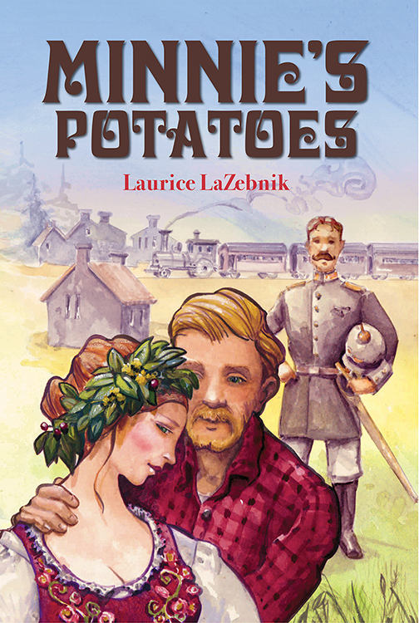

3rd novel by Laurice LaZebnik, “Minnie’s Potatoes,” released through Amazon’s CreateSpace March 2016 in paperback and Kindle

ISBN 9781523753970

Price $14.99, 379 pages.

Reviews/Endorsements

Minnie's Potatoes … offers a dramatized account of a family's extraordinary genealogical history … the writing is generally crisp … the story is a gripping one … often mesmeric, and charged with erotic electricity."
— Kirkus Review

“Minnie’s Potatoes has that Laura Ingalls Wilder appeal at a mature level. This historical romance is an adult “Little House on the Prairie” set in Michigan’s lumbering era and follows it’s path through Prohibition.”
— Valerie Valentine, Independent book editor

(Minnie’s Potatoes) … reminded me of the work of Willa Cather in O Pioneer! or My Antonia – wonderful books where the women are intimately connected with the land they live on and love.
— Ann Green, Emeritis Professor of English, Jackson College

“Milking every drop of drama from her narrative, LaZebnik loads it with vivid descriptions, thoughtful observations, and suspense. Where the novel particularly stands out is that the author has a gift for evoking the luminous joys and dark pains that color every family as well as their way of life in a bygone era, making them seem as vivid and immediate as something that transpired only yesterday. And not only is the narrative an empathetic and searing family saga but it is also an intimate portrait of lives that never seem less than real involving the author's great-grandparents as they absorbed the odd customs of America. Not to leave out it is an attestation to her great-grandfather's astute foresight in purchasing and clearing lands in various areas of Michigan and giving them to his sons as well as to three generations that still bear the Hartman name.”
— Norm Goldman, reviewer, Goodreads.com

Author’s Personal & Professional Background

I've been involved with storytelling all my life. My earliest memory of hearing stories was when I was around four or five. I remember sitting on the porch swing with my grandfather waving at cars that passed by on our dusty road. Between the cars Grandpa told me what it was like on the ship when he came to America and of the animals he encountered when he was a cook in the timber woods. My father made up stories after dinner each night to entertain us. The mutation on the gene that causes storytelling must have been passed down from them to me. Oh, I've done a few things since then … taught high school, started a storytelling festival that has run 29 years and learned to fly an airplane. Nothing has been as rewarding to me than writing stories. "Minnie's Potatoes" is my third novel.

BS in Education, Art/English, Central Michigan University 1962-70
Taught students art and English at Northwestern HS in Flint, & Chelsea HS. 1970-76
Marketing and Sales Manager, Airmaster Fan Company 1976-85
Property Manager, The Commercial Exchange 1985-98

Author’s Contact

Please direct all question to Laurice via Email: laurl@sbcglobal.net
Read more of her work online at her website and blog: www.lauricelazebnik.com
Visit her on Facebook at: https://www.facebook.com/LauriceLaZebnikStories/?fref=ts

